*A project report on*

Crop Yield Prediction Using Drone

*Submitted in partial fulfillment for the award of the degree of*

Computer Science and Engineering

*For*

*CSE1901 Technical Answers to Real World Problems*



*By*

Rochak Shrivastav 20BCE1814

Biradar Shailesh 20BCE1845

MD Ayan Zafar 20BCE1851

Aakash Goyal 20BCE1617

*Under the Guidance of*

Geetha S.

**SCHOOL OF COMPUTER SCIENCE AND ENGINEERING**

December 2023

School name: School of Computing Science and Engineering

Faculty name (ERP No): S.Geetha, (50587)

Academic Year: 2023-24 (Fall Semester 23-24)

Title of the project: Crop Yield Prediction using Drone

Number of students involved in this project: 4

 

Rochak Shrivastav 20BCE1814 Biradar Shailesh 20BCE1845

 

MD Ayan Zafar 20BCE1851 Aakash Goyal 20BCE1617

Table of Contents

|  |  |
| --- | --- |
| Chapter 1: Introduction | 1 |
| * 1. Abstract | 1 |
| * 1. Motivation | 1 |
| 1.3 Problem statement | 1 |
| Chapter 2: Methodology | 2 |
| 2.1 Product Component Specification | 2 |
| 2.2 Drone Construction | 4 |
| 2.3 Fire Detection | 5 |
| 2.4 Crop Classification | 5 |
| 2.5 Crop Yield Prediction | 5 |
| 2.6 Aerial Seeding | 5 |
| Chapter 3: Architecture | 6 |
| 3.1 Crop Classification | 6 |
| 3.2 Crop Yield Prediction | 6 |
| 3.3 Fire Detection | 7 |
| 3.4 Aerial Seeding | 7 |
| 3.5 Modules of drone | 8 |
| Chapter 4: Implementation | 9 |
| 4.1 Crop Classification | 9 |
| 4.2 Crop Yield Prediction | 10 |
| 4.3 Fire Detection | 10 |
| 4.4 Aerial Seeding | 10 |
| Chapter 5: Results | 11 |
| Chapter 6: Outcomes | 12 |
| Chapter 7: Single Unique Factor | 13 |
| Chapter 8: Site Visit | 13 |
| Chapter 9: Sample Codes | 13 |
| Chapter 10 References | 13 |

List of Figures:

Frame

Bldc motors

Flight controller

Electronic speed controls(ESC)

RF receiver

Battery

Propellers

Arduino UNO

Servi Motor

Camera

Fig 3.1: pixhawk connection diagram

Fig 3.2: arming switch

Fig 3.3: telemetry unit

Fig 4.1: Implementation of crop classifier

Fig 4.2: Camera For Drone

Fig 4.3: Drone for capturing images and aerial seeding

Fig 4.4: Implementation of Crop yield Prediction

Fig 4.5: Implementation of Fire Detection

Fig 4.6: Aerial Seeding Circuit structure

Chapter 1: Introduction

Agriculture is an important part of the global economy and provides livelihoods to thousands of people. As technology continues to advance many industries, precision agriculture is becoming a transformative force in optimizing agriculture. A key aspect of this change is the integration of drones equipped with advanced sensors and machine learning algorithms to improve monitoring and crop management.

* 1. Abstract:

The project "Crop Yield Prediction using Drone" harnesses the capabilities of modern drone technology to revolutionize traditional farming methods. Our drone is equipped with a high-resolution camera for capturing images of crops, a machine learning model for crop classification, and sensors for monitoring environmental conditions. Additionally, the drone features an aerial seeding mechanism for efficient and targeted crop planting, along with a fire detection sensor to enhance farm safety. The system aims to predict crop yield, optimize resource usage, and contribute to sustainable and efficient agricultural practices.

* 1. Motivation:

Traditional farming practices often face challenges such as inefficient resource utilization, labor-intensive processes, and delayed response to environmental threats. The motivation behind our project is to address these challenges by leveraging the capabilities of drones and artificial intelligence. By employing machine learning algorithms, we aim to provide farmers with timely and accurate information on crop types, water requirements, and pest management. The inclusion of an aerial seeding mechanism further streamlines the planting process, while the fire detection sensor enhances the safety and security of agricultural operations.

* 1. Problem statement:

The agricultural sector faces persistent issues related to crop management, resource allocation, and timely response to potential threats. Conventional farming methods often lack precision and real-time monitoring capabilities, leading to suboptimal yields and resource wastage. The specific problems addressed by our project include:

1. Crop Classification: Traditional methods of identifying crops are time-consuming and error-prone. Our project seeks to accurately classify crops, namely rice, corn, bajra, and sugarcane, using drone-captured images and machine learning algorithms.
2. Resource Optimization: Farmers often struggle to determine the optimal amount of water and pesticides required for different crops. Our system aims to predict the ideal resource allocation based on the type of crop and the area of farming.
3. Efficient Seeding: Traditional seeding methods can be labor-intensive and less precise. The inclusion of an aerial seeding mechanism in our drone aims to enhance the efficiency and accuracy of crop planting.
4. Fire Detection: Agricultural fields are susceptible to fire hazards, which can lead to significant crop loss. Our project incorporates a fire detection sensor to identify and respond to potential fire incidents in a timely manner.
5. By addressing these challenges, our project aims to contribute to the advancement of precision agriculture, promoting sustainable and efficient farming practices for the benefit of farmers and the agricultural industry as a whole.

**Chapter 2 Methodology:**

* 1. **Product Component Specification:**

|  |  |  |
| --- | --- | --- |
| Product | Product Specification | Use Case |
| Frame | Q450 Glass Fiber 330 mm Quadcopter frame | It’s the base frame on top of which the entire drone system is built |
| Brushless DC Motor 1000kv | BLDC Motor for Quadcopter : Amazon.in:  Industrial & Scientific  BLDC Motors | A2212 1000 KV BLDC Motors | Motors rotate the propellers to provide up thrust to fly. We specifically use BLDC which provide high RPM to generate required thrust. |
| Pixhawk 2.4.8 Drone Flight Controller PX4 32 Bit Autopilot Flight Control  Board : Amazon.in: Industrial & Scientific  Flight Controller | Pix-Hawk PX4 2.4.8 Flight Controller | Controller is used to provide movement commands manually. This has GPS, Gyro meter, accelerometer, magnetometer included in it |
| Buy UG LAND INDIA 30 amp 30A Brushless Motor Speed Controller RC BEC ESC (electronic  speed controller) for Quadcopter Plane Helicopter, Drone Quadcopter Science  Project - Yellow Online at Low Prices in  Electronic Speed Controls  (ESC) | 30A ESC with in-built BEC | ESC is the brain of the motor. It generates PWM to run the dc motor depending on the speed requirement received from the flight controller. |
| RF Reciever | FlySky FS-iA6B 2.4GHz 6 Channel Receiver | This receives manual commands from Transmitter from Ground Station which specify the direction of flight to the drone |
| Transmitter and Receiver for Drones | by Aditya Kekre | Medium  RF Transimitter | FlySky FS-iA6B 2.4GHz 6 Channel Transmitter | This is the transmitter that we used for testing purposes during manual flight. |
| Wholesale Li Polymer 5000mAh 60c 11.1V High Discharge Battery Pack - China 11.1V  5000mAh Lipo Battery and 3s Drone Battery price | Made-in-China.com  Battery | 11.1V 5000mAh Lithium Ion Battery | Battery to Power the Entire System |
| IZI Shift Drone Propeller Blades Set of 4 Propellers Lightweight and High  Strength Propeller Help to Improve The Air-Powered Efficiency and Aerofoil  Stability-Accessory Only : Amazon.in: Toys & Games  Propellers | 1045 carbon fibre Propellers | Provides direction and thrust. |
| Arduino Uno | Arduino UNO Microcontroller | For Performing Aerial Seeding Instruction Processing |
| TowerPro SG 90 Micro Servo Motor : Amazon.in: Industrial & Scientific  Servo Motor | Servo Motor | Motor to perform opening and closing in aerial seeding |
| SJCAM SJ4000 Air 4K Wi-Fi 16MP Action Camera - SJCAM  Camera | SJ4000 Wifi integrated camera | Camera to capture images |

* 1. **Drone Construction:**

1. Frame Assembly:

Begin by carefully assembling the Q450 frame, following the manufacturer's instructions. Make sure all frame components are securely attached and the frame structure is solid and consistent**.**

1. Motor Installation:

Mount the A2212 1000 KV BLDC Motors on each arm of the frame, using the provided screws. Pay careful attention to the alignment, ensuring that the motors are securely fastened and straight.

1. Flight Controller Setup:

Connect the Pix-Hawk PX4 Flight Controller to the frame. Refer to the wiring diagram provided with the controller to ensure the correct connections. Position the flight controller centrally on the frame for optimal balance.

1. ESC Connection:

Attach the 30A ESCs to each motor and connect them to the Pix-Hawk PX4 Flight Controller. Employ proper soldering techniques and cable management to prevent any interference issues.

1. Receiver and Transmitter Pairing:

Initiate the binding process between the FlySky FS-iA6B Receiver and the FlySky FS-iA6B Transmitter, adhering to the manufacturer's instructions. Verify a stable connection before proceeding.

1. Power system Integration:

Connect the 11.1V 5000mAh Lithium-Ion Battery to the power distribution board. Double-check all connections to ensure there are no loose wires that could compromise the system's integrity.

1. Propeller Attachment Testing:

Securely mount the 1045 carbon fiber propellers onto each motor shaft. Confirm that the propellers are firmly attached and rotate freely without any obstructions.

After Successful Drone Construction, we can use it to fly using RF Transmitter

* 1. **Fire Detection:**

MobileNet, a pretrained convolutional neural network, CNN, is used in the model to detect fire in the image. The process involves transfer learning, where MobileNet is adapted to the task without retraining from scratch. By modifying its architecture, the model can be configured for binary classification options of fire or nonfire. Freezing most layers ensures that pretrained weights are retained, while only newly added layers can be correctly tuned to a specific dataset. The models adjust their weights while training, based on marked images of fires and other scenarios. The training process shall be guided by a consolidated crossentropy loss function and an Adam optimizer. The model will be able to detect whether the new image contains fire or is not based on established patterns, when it has been trained.

* 1. **Crop Classification:**

For crop classification in a dataset which has not been labeled, the VGG16 model is used as an extensive convolution neural network to perform image classification tasks. The model learns to recognize hierarchical patterns and features in crop images by combining convolutional layers for feature extraction, pooling layers for down sampling or fully connected layers for prediction. During training, the model will use unlabeled data sets and optimize their parameters in order to minimize loss function using backpropagation. In the inference phase, when an image is inputted, the model's convolutional layers extract features, and the fully connected layers generate predictions, ultimately outputting a probability distribution over possible crop classes. The crop has been forecast on the basis of the greatest probability. To use the model, you simply input the image and the VGG16 model provides the predicted crop class, using the knowledge acquired from the training data base.

* 1. **Crop Yield Prediction:**

The first step of this crop yield prediction workflow will be to normalize input features, using a MinMax scaling algorithm. This ensures that all the features will be uniformly reflected in a model and so prevent any one feature from affecting its learning process. In addition, the dataset shall be split according to training sets comprising 75 % and testing sets of 25 %. This division makes it easier for a model to be evaluated on its predicted performance. RandomForestRegressor from Scikitlearn, configured with 501 decision trees, is the predictive model used in this scenario. The robustness and accuracy of the model in predicting crop yields are improved through this combination learning approach. After that, the model will be calibrated according to its scaled features and related crop yield marks which are included in the training package. With the model trained, predictions are generated for the test set, providing estimated crop yield values.

* 1. **Aerial Seeding:**

The aerial seeding mechanism integrates a drone, Arduino, and servo motor to execute a precise and autonomous seed dispersal process. Upon activation, a 30-second timer initiates, allowing the drone to navigate and position itself accurately. Subsequently, control is handed over to the servo motor, connected to the Arduino, which manages the opening and closing of the seed container. The servo motor follows a predefined sequence, releasing seeds at regular 5-second intervals. This autonomous cycle repeats until the system is turned off or completes a predetermined number of dispersal cycles. Consideration is given to energy management, ensuring the drone's battery can support the additional load.

**Chapter 3 Architecture**

* 1. **Crop Classification:**

1. Input Processing:

Input image undergoes convolutional layers. Convolutional layers extract hierarchical features (e.g., edges, textures).

1. Spatial Reduction:

Pooling layers follow convolution to downsample features. Reduces spatial dimensions and aids computational efficiency.

1. Flattening:

Processed features are flattened into a one-dimensional vector. Prepares features for interpretation by fully connected layers.

1. Decision Making:

Fully connected layers combine high-level features for predictions. Adjust internal parameters during training to minimize prediction errors.

1. Training Phase:

Unlabeled dataset utilized for training. Backpropagation adjusts parameters to minimize the difference between predictions and actual outcomes.

1. Inference Phase:

Unseen image passes through the trained network. Convolution extracts features, pooling reduces dimensions, fully connected layers make predictions.

1. Output:

Model outputs a probability distribution over crop classes. Highest probability determines the predicted crop.

1. User Utilization:

Users input images for classification. VGG16 processes images through sequential steps. Provides a prediction based on learned knowledge from the training data.

* 1. **Crop Yield Prediction:**

1. Feature Scaling:

The first step will be to scale input features, using MinNoMax scaling. This normalizes so that all features can be consistent at the same level, which prevents any single feature from overwhelming the model's learning process.

1. Data Splitting:

Datasets are broken down into two subsets: training sets and testing sets. For the training of the model, 75% of the data are used and 25% for testing purposes with a view to evaluating its predictive performance.

1. Random Forest Regressor Initialization:

A Random Forest Regressor from scikitlearn is the key model used to predict crop yields. The configuration which specifies 501 decision trees is initialized. In order to increase the robustness and efficiency of this model, RandomForestRegressor relies on ensemble learning.

1. Training the Model:

The RandomForestRegressor is taught in the training set where scaled features serve as input, and relevant crop yield labels are used to determine the target value. Through a network of decision trees, the model will learn how to distinguish between features and crop yields.

1. Prediction on Test Set:

When trained, the model will be used to produce predictions for a set of tests. The model is loaded with the scaled features of the test series and RandomForestRegressor generates predicted crop yields.

* 1. **Fire Detection:**

1. Input Layer:

The model takes images as input, and the input layer (`input_1`) expects images of size 224x224 pixels with 3 color channels (RGB).

1. Initial Convolutional Layers:

The input goes through initial convolutional layers (conv1, conv1_bn, conv1_relu) to extract basic features.

1. Depthwise Seperable Convolutions:

The model employs depthwise separable convolutions (e.g., conv_dw_1, conv_pw_1) for more efficient feature extraction. These layers capture spatial information and reduce computational cost.

1. Multiple Stacks of Convolutional Blocks:

The model repeats a series of convolution blocks, each with its own depthwise synchronous convolutions, batch normalization and ReLU activation. At the various abstraction levels, these blocks are capturing a series of hierarchy features.

1. Global Average Pooling:

The spatial dimensions of the features have been reduced to a single value per channel by global average pool layer, global_average_pooling2d. It enables the model to be more robust and allows for a fixed output regardless of its input size by means of spatial translation.

1. Reshape and Dropout:

Reshape and dropout layers (reshape_1, dropout) are applied to introduce some regularization and prevent overfitting during training.

1. Final Dense Layer:

A custom layer for binary classification is created in the final density layer. It displays the probability of an input image belonging to two classes, Fire or Nonfire, using two output units that have a softmax activation function.

1. Model Output:

A probability distribution between these two classes is generated by the model. The model learns to compensate for the loss of categorical crossentropy by adjusting its weights through backproxation during training.

1. Freezing Layers:

During training, each layer is frozen except for the last dense layer. This means that, on a specific fire detection dataset, weights remain fixed for most of the model pretrained in MobileNet and only their last layer's weights have been adjusted.

* 1. **Aerial Seeding:**

1. Drone:

A drone equipped with navigation and positioning capabilities is the core platform. It's using sensors and controls to control autonomously where the seeding should take place.

1. Arduino Microcontroller:

The Arduino is a part of the system's brain, which manages and coordinates its various components. It is capable of receiving input from sensors and processing control algorithms and transmitting commands to the servo motor.

1. Servo Motor:

Connected to the Arduino, the servo motor controls the opening and closing of the seed container. It follows a predefined sequence, releasing seeds at specified intervals.

1. Seed Container:

Seeds are kept and dispensed from the seed container. It's attached to the servo motor, meaning that it can be controlled and precisely released of seeds.

1. Timer System:

The timer system, either implemented in the Arduino code using functions like delay() or millis(), ensures the drone has an initial period of 30 seconds to position itself before the seed dispersal sequence begins.

1. Power Supply:

The electrical energy required for the operation of the system shall be supplied by power supply systems, mostly drones' batteries. In order to maintain the optimal performance of drones, it is essential to take into account energy consumption.

* 1. **Modules of Drone:**

1. Pixhawk Flight Controller:

32-bit arm cortex M4 core with FPU

32-bit failsafe co-processor

Bus interface (UART, I2C, SPI, CAN).

Firmware: Mission planner.

Sensors: Gyro meter, Accelerometer, Barometer & Magnetometer

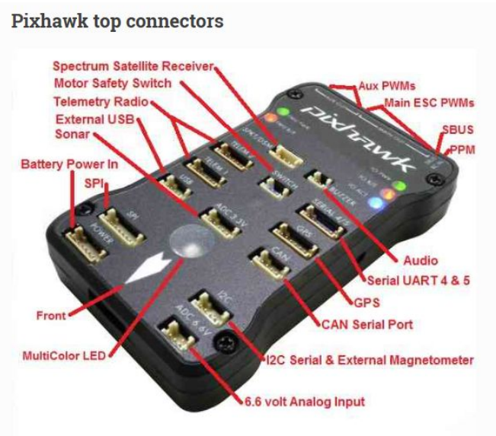

Fig 3.1: Pixhawk Connections diagram

1. Arming Switch:

Allows the user to power on and off the UAV. It is connected to the switch port of the Pixhawk.

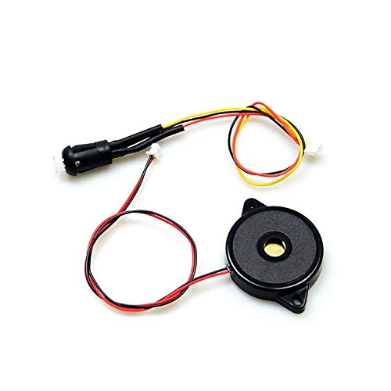

Fig 3.2: Arming Switch

1. Telemetry:

Telemetry is the automatic recording and transmission of data from remote or inaccessible sources to an IT system in a different location for monitoring and analysis. Telemetry data may be relayed using radio, infrared, ultrasonic, GSM, satellite or cable, depending on the application Pair of two devices. One of them will be connected to the telemetry port of the PIXHAWK board. The other one will be connected to a tablet which will be operated from the ground. Telemetry works through sensors at the remote source which measures physical (such as precipitation, pressure or temperature) or electrical (such as current or voltage) data. This is converted to electrical voltages that are combined with timing data. They form a data stream that is transmitted over a wireless medium, wired or a combination of both. At the remote receiver, the stream is disaggregated and the original data displayed or processed based on the user’s specifications

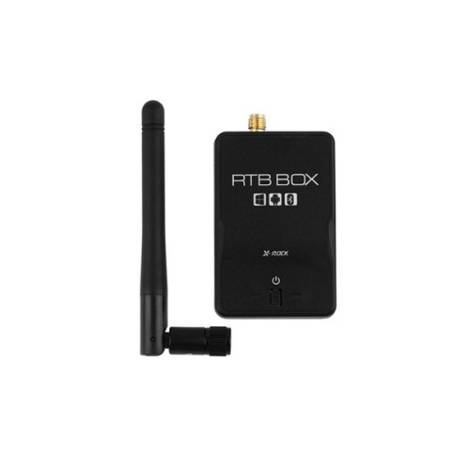

Fig 3.3: Telemetry unit

**Chapter 4 Implementation**

* 1. **Crop Classification:**

Implementation involves a simple process so that crop classification is as easy as possible. It is simple for users to submit an image input captured from drone using camera and a classifier will be instantly able to identify the crop type. A classification system shall be designed to identify a variety of crops such as jute, rice, maize, sugarcane and wheat. This user-friendly system facilitates the identification of crops and allows them to be used for agricultural applications in a more efficient way. Simply input an image, and the classifier delivers the corresponding crop name with ease.

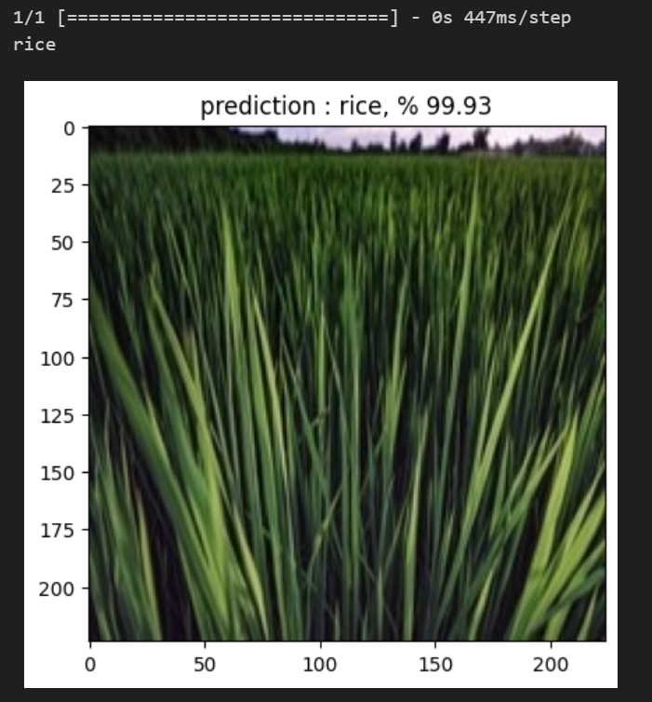

Fig 4.1: Implementation of crop classifier

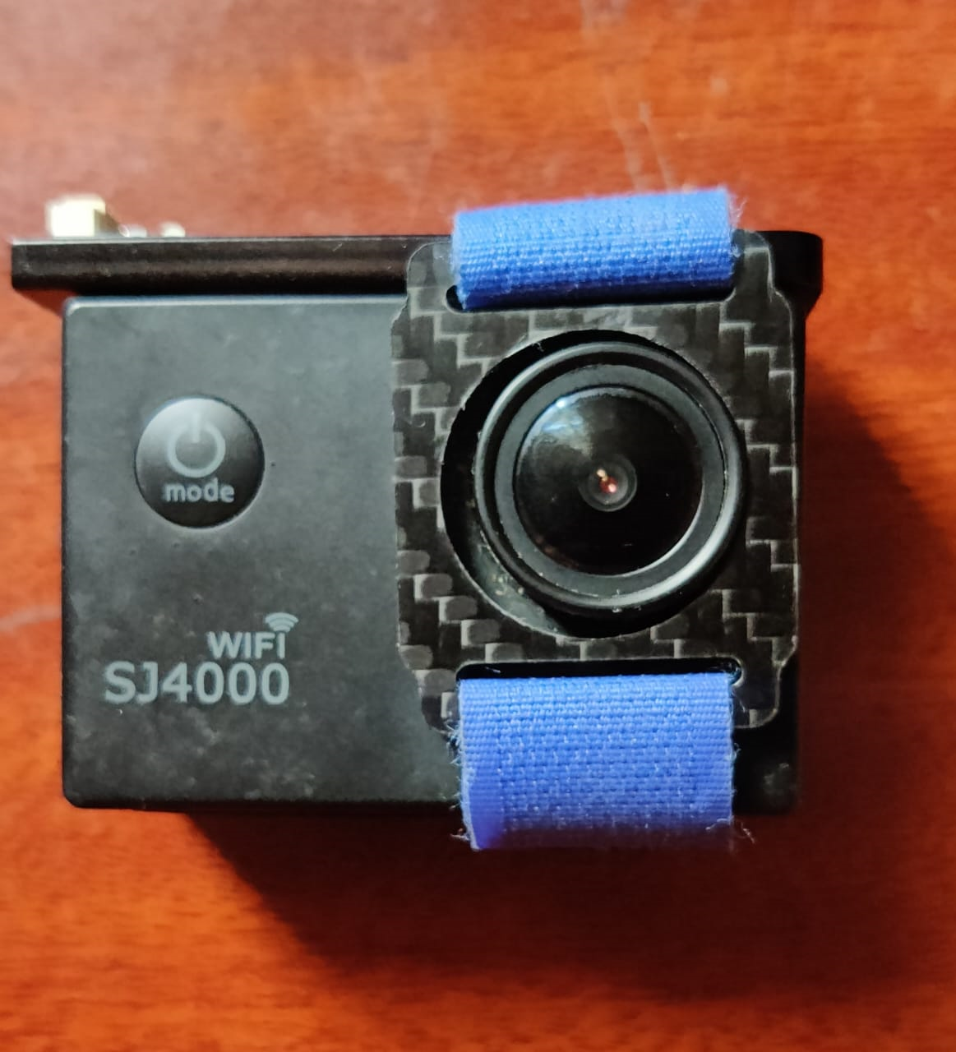

Fig 4.2: Camera For Drone

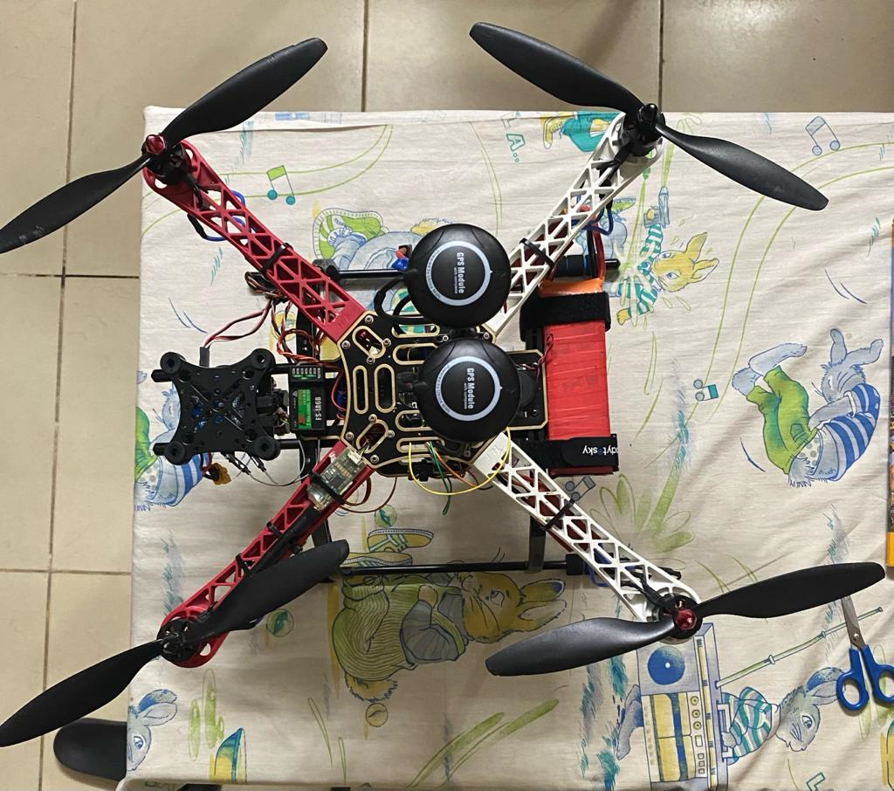

Fig 4.3: Drone for capturing images and aerial seeding

* 1. **Crop Yield Prediction:**

Our crop yield prediction and recommendation system operate through a straightforward yet effective process, providing insights and suggestions based on input parameters. The implementation involves the following steps:

1. User Input:

Users input relevant agricultural parameters, including the area in hectares, average temperature, average rainfall in millimeters, and the quantity of pesticides used in tones.

1. Yield Prediction:

The system utilizes these input parameters to predict the crop yield and production in kilograms. This prediction serves as a pivotal indicator for decision-making in agricultural practices.

1. Yield based suggestion:

Following the yield prediction, the system generates practical suggestions tailored to the predicted yield. These suggestions aim to guide farmers in optimizing their agricultural practices for better outcomes.

* If the predicted yield surpasses a predefined threshold (e.g., 26053 kg): "Consider optimizing irrigation to prevent water stress."
* If the predicted yield falls below the threshold: "Evaluate soil quality and consider fertilization or soil amendments."
* If the yield is within an acceptable range: "Continue monitoring and adjusting practices based on real-time data."

1. Environmental Recommendations:

In addition to yield-based suggestions, the system provides recommendations based on environmental factors. These suggestions are geared towards optimizing crop growth and minimizing negative impacts.

* If the average temperature exceeds a specified threshold (e.g., 16.18°C): "Monitor crop stress due to high temperatures and provide shading or cooling if needed."
* If rainfall is below a certain level (e.g., 1254 mm): "Implement efficient irrigation practices to ensure sufficient water supply."
* If the quantity of pesticides used is above a predefined limit (e.g., 20303 tones): "Evaluate and potentially reduce pesticide usage to minimize environmental impact."

1. User Feedback and adjustment:

Users receive these suggestions and can adapt their agricultural practices based on the recommendations provided. This iterative feedback loop allows farmers to make informed decisions to enhance crop yield and sustainability.

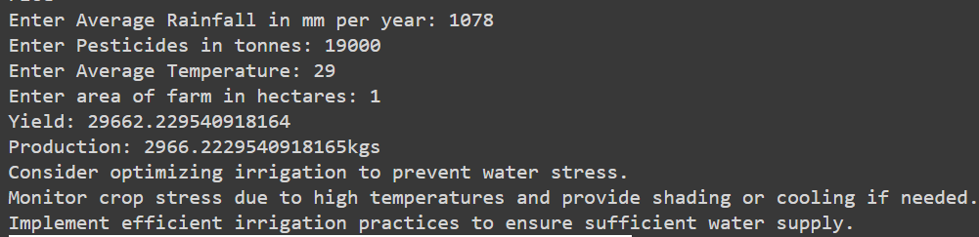

Fig 4.4: implementation of Crop yield Prediction

* 1. **Fire Detection:**

The image classification model of ours is designed so that the presence of fire can easily be detected and crops are classified with great precision. The model shall immediately ascertain whether the image is depicting a scenario of fire upon input of an image. An easy interface provides a seamless experience and enables predictions in fire detection to be easily obtained

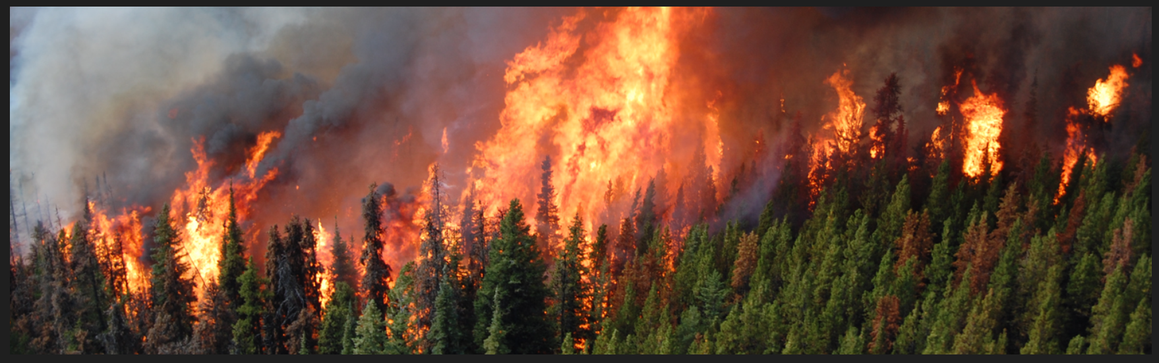

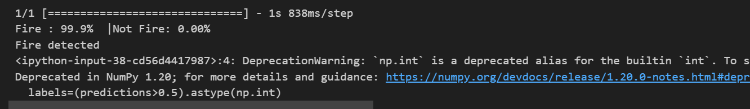

Fig 4.5: Implementation of Fire Detection

* 1. **Aerial Seeding:**

There is no difficulty in implementing the aerial seeding mechanism. When the system has been activated, a 20 second timer will be started to ensure that the drone achieves its target position. The drone will begin to disperse the seeds following this first period. You simply fill a container with seeds that are attached to the drone. The package opens every 5 seconds and seeds are released in the selected area. This process will continue while the drone's mission is under way or until such time as a manual switch has been disabled. This process is easy to implement as it involves a timing sequence, managed by the onboard timer and basic operation of the seed box, which makes this an efficient solution for air seeding.

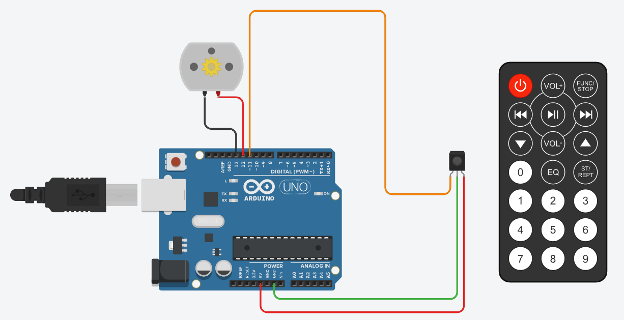

Fig 4.6: Aerial Seeding Circuit structure

**Chapter 5 Results**

Crop Identification Module: The Crop Identification Module is the foundation of precision agriculture, using technology to transform the way farmers monitor and manage their crops. The module is equipped with a high-resolution drone camera that captures unique details of crops such as wheat, maize, bajra and sugar. The resulting images give farmers a quick understanding of crop health and growth, allowing them to make informed decisions based on each crop's unique needs. The reality of crop identification goes beyond simple crop identification; It forms the basis of decision-making information in agriculture. Farmers can tailor their strategies to each crop's unique characteristics and needs. This not only simplifies the maintenance of the system, but also improves the management of the entire crop. The module provides accurate and timely information that helps increase crop yields and promote sustainable agriculture in line with the needs of today's agriculture. The model is able to identify crops with an accuracy of 91.9%.

Aerial Seeding Mechanism: Aerial Seeding Mechanism has revolutionized the method of seed planting, providing an effective and precise method that can improve large-scale agriculture. This precision planting system is seamlessly integrated into the drone and continuously spreads the seeds to ensure even coverage across the field. Aerial seeding mechanisms solve labour-intensive problems associated with traditional seeding methods by optimizing the seeding process. This mode plays an important role in increasing the yield as well as saving time and resources. The precision of seed distribution maximizes the plant's ability to see growth, helping to increase the overall productivity of the agricultural sector. Farmers benefit from efficiency and resource utilization, making the module an important tool for modern permaculture practices. The drone operates at a battery life of nearly 20 to 30 minutes.

Predictive Resource Management: The Predictive Resource Management module represents a step forward in agricultural technology by providing farmers with powerful tools for efficient use of resources and environmental safety. This model takes the location of the crop as input and uses predictive models to calculate water and pesticide requirements for crop growth. This decision allows farmers to be informed by data so they can make informed decisions about the allocation of resources. The module promotes environmental protection and permaculture by preventing unnecessary water use and reducing pesticide use. The module's predictive capabilities allow farmers to manage resources, adapt to changes and maximize the long-term profitability of their farming. Predictive resource management, the core concept of precision agriculture, enables farmers to navigate the complexities of modern agriculture and balance production and environmental responsibility. The model is able to predict yield with an accuracy of 96.5%.

Fire Detection Sensors: Integrated fire detection sensors drones are one of the important products designed to increase the safety of agriculture. With the use of technology, the sensor can detect small signs of fire in agricultural areas and prevents crops from being damaged by fire by intervening in time. As wildfires become more of a threat, fire detectors can be used as countermeasures to reduce the risk. In fact, real-time monitoring capability provides farmers with significant protection for their crops, protects investments, and increases agricultural protection against unprecedented threats. The module goes beyond traditional precision agriculture; It addresses the growing challenges of climate-related disasters and highlights the importance of technology in promoting sustainable and resilient agriculture. With fire detectors, farmers can quickly respond to the possibility of fire in the face of changing environmental challenges, reducing the impact on crop productivity, and improving the safety of farming operations. The model is able to detect fire with an accuracy of 95%.

YouTube Video Demo: <https://youtu.be/X1296-6z2m4>

Chapter 6 Outcome

The results of the program, which uses drones to predict crop yields, are revolutionary, changing traditional agriculture and ushering in a new era of precision agriculture. One of the most important achievements is the accurate identification of crops through high-resolution drone images. This capability allows farmers to quickly view crop health and growth, making decision making easier. The integration of air seeding mechanisms simplifies the seeding process, providing unparalleled efficiency in covering large areas for agricultural expansion. The ability of drones to continuously deliver seeds to disperse crops, improve resource use, and help increase crop yields. This result has a great impact on large-scale agriculture because it solves the problem of labor-intensive work while improving resources. The project's predictive modeling, which calculates the area allocated to agriculture according to water and pesticides, is a game changer for the capital management layer. Farmers will now be able to receive specific advice on how to use water and pesticides, reduce water waste and reduce the environmental impact of overuse of pesticides. These benefits not only improve the economics of agriculture but also encourage permaculture practices. In addition, the integration of electronic devices discovers additional important methods of plant protection. The system can quickly detect signs of fire and intervene early, preventing crop loss due to fire. This event highlights the program's commitment to ensuring the sustainability of agricultural investments. Essentially, the event resulted in efficient operations, optimization of resources and encouraging farmers to make the right decisions. As agriculture continues to face challenges such as climate change and changing business needs, the use of drones to predict crop yields has become a new beacon offering strategic solutions to move agriculture into the future and technology.

Chapter 7 Single Unique Factor

As our crop forecasting project using drones shows, the integration of technology into agriculture demonstrates a perfect combination of innovation and sustainability. Many unique features differentiate our project from others, highlighting its impact on agriculture today. First of all, the use of drones equipped with advanced cameras for product detection is a breakthrough in agriculture. Capturing detailed images of crops such as wheat, maize, bajra and sugar, the system has demonstrated its potential to improve monitoring and decision-making in agriculture. This not only helps identify the crop, but also provides recommendations based on each crop's specific needs. The inclusion of air planting techniques further demonstrates the innovative approach of the project. The ability of drones to continuously disperse seeds demonstrates the ease and efficiency of large-scale planting. This not only saves time, but also improves resource use and contributes to permaculture practices. The prediction of the program is also good, the system calculates water and medicine according to the area given for planting. This not only simplifies the management of resources, but also promotes sustainable and more profitable agriculture. The ability to adjust the recommendations for each product indicates the flexibility of the project for different farms. Additionally, electronic sensors on the drone add an extra layer of security and reduce risk. By detecting the smallest signs of fire, the system can facilitate early intervention, prevent crop damage, and protect agricultural investment. This suggests a holistic approach to crop management that goes beyond yield prediction. In summary, our project represents a multifaceted approach combining planting, precision planting, capability estimation and firefighting. The combination of these technologies not only improves agriculture, but also demonstrates the potential of drone-based systems to revolutionize modern agriculture. Celebrating the project's one-year milestone is a testament to future advancements in integrated technology and agriculture

Chapter 8 Site Visit

Our group set out for an innovative agricultural experiment using the cutting-edge drone during our recent visit to a farm near my college campus. We flew in a seamless flight over the skies, carefully exploring various aspects of precision farming under the professional guidance of certified drone pilots. I managed to identify crops that were remarkably accurate and enhance our understanding of the varied vegetation on the farm, using sophisticated image processing techniques. In addition, our drone has made a major contribution to the prevention of fires through image processing and contributed to preventive measures aimed at protecting rural areas. The use of image processing for the prediction of yields has been further expanded, which will allow us to make informed decisions as to how much we are going to harvest. For the first time, we've used a drone to seed an agricultural field in order to demonstrate its potential as environmentally friendly farming technology. This site visit not only expanded our knowledge but also underscored the transformative impact of technology on modern agriculture.

Chapter 9 Sample Codes

Github Link: <https://github.com/07Rochak/Crop-Classification-and-Yield-prediction>

Chapter 10 References

1. W. Budiharto, A. Chowanda, A. A. S. Gunawan, E. Irwansyah and J. S. Suroso, "A Review and Progress of Research on Autonomous Drone in Agriculture, Delivering Items and Geographical Information Systems (GIS)," 2019 2nd World Symposium on Communication Engineering (WSCE), Nagoya, Japan, 2019, pp. 205-209, doi: 10.1109/WSCE49000.2019.9041004.
2. Dutta G, Goswami P. Application of drone in agriculture: A review. International Journal of Chemical Studies. 2020;8(5):181-7.
3. Abderahman Rejeb, Alireza Abdollahi, Karim Rejeb, Horst Treiblmaier, Drones in agriculture: A review and bibliometric analysis, Computers and Electronics in Agriculture, Volume 198, 2022, 107017, ISSN 0168-1699.
4. Abdul Hafeez, Mohammed Aslam Husain, S.P. Singh, Anurag Chauhan, Mohd. Tauseef Khan, Navneet Kumar, Abhishek Chauhan, S.K. Soni, Implementation of drone technology for farm monitoring & pesticide spraying: A review, Information Processing in Agriculture, Volume 10, Issue 2, 2023, Pages 192-203, ISSN 2214-3173
5. Ivezić, A., Trudić, B., Stamenković, Z., Kuzmanović, B., Perić, S., Ivošević, B., Buđen, M. and Petrović, K., 2023. Drone-Related Agrotechnologies for Precise Plant Protection in Western Balkans: Applications, Possibilities, and Legal Framework Limitations. *Agronomy*, *13*(10), p.2615.
6. Meshram, V., Patil, K., Meshram, V., Hanchate, D. and Ramkteke, S.D., 2021. Machine learning in agriculture domain: A state-of-art survey. *Artificial Intelligence in the Life Sciences*, *1*, p.100010.
7. Mourtzinis, S., Esker, P.D., Specht, J.E. and Conley, S.P., 2021. Advancing agricultural research using machine learning algorithms. *Scientific reports*, *11*(1), p.17879.
8. Durai, S.K.S. and Shamili, M.D., 2022. Smart farming using machine learning and deep learning techniques. *Decision Analytics Journal*, *3*, p.100041.
9. Borikar, G.P., Gharat, C. and Deshmukh, S.R., 2022, October. Application of Drone Systems for Spraying Pesticides in Advanced Agriculture: A Review. In *IOP Conference Series: Materials Science and Engineering* (Vol. 1259, No. 1, p. 012015). IOP Publishing.
10. KATEKAR, V. and CHERUKU, J.K., 2022. The Application of Drone Technology for Sustainable Agriculture in India. *Current Agriculture Research Journal*, *10*(3).
11. Raj, K.M., Balaji, N., Vairavel, K.S., Sharmila, P., Azhagumurugan, R. and Jayakushal, S., 2022, November. IoT Based Agricultural Drones for Pest Control. In *2022 1st International Conference on Computational Science and Technology (ICCST)* (pp. 134-137). IEEE.
12. Raj, A.Y., Venkatraman, A., Vinodh, A. and Kumar, H., 2021, February. Autonomous Drone for Smart Monitoring of an Agricultural Field. In *2021 7th International Engineering Conference “Research & Innovation amid Global Pandemic"(IEC)* (pp. 211-212). IEEE.
13. Spoorthi, S., Shadaksharappa, B., Suraj, S. and Manasa, V.K., 2017, February. Freyr drone: Pesticide/fertilizers spraying drone-an agricultural approach. In *2017 2nd International Conference on Computing and Communications Technologies (ICCCT)* (pp. 252-255). IEEE.
14. Nayyar, A., Nguyen, B.L. and Nguyen, N.G., 2020. The internet of drone things (IoDT): future envision of smart drones. In *First International Conference on Sustainable Technologies for Computational Intelligence: Proceedings of ICTSCI 2019* (pp. 563-580). Springer Singapore.